ROCKY MOUNTAIN KUNG FU TRAINING CENTER Presents the  22nd ANNUAL SUMMER CAMP | 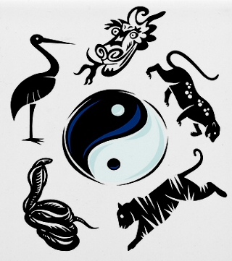
WHEN: Saturday JULY 23th – Saturday JULY 30st, 2011
WHERE: ROCKY MOUNTAIN KUNG FU TRAINING CENTER
WHAT: CHAIN WHIP
WHO: SIFU DAVID SIMEONE

We are pleased to invite you to the 22nd annual Kung Fu Summer Camp! This year offers a very special unique opportunity for you to train in the way of the ancient Shaolin warriors! The schedule consists of intensive training, 5 days a week, 6 hours a day, for a week, interspersed with work, study, relaxation, and fun!
The Rocky Mountain Kung Fu Training Center is located approximately 18 miles outside of Woodland Park, Colorado on the western slope of the majestic Pikes Peak, at an altitude of 10,500 feet. This serene setting provides the perfect place for committing to train in the tradition and ancient arts of the Taoist and Shaolin masters.
Students are provided with rustic, separate male & female quarters, a main mess hall, a central fire pit, drinking water, and an outhouse. Shower & recreational facilities (pool) will be available in nearby Cripple Creek for an additional $5 per person. We ask that there be no camp fires. If you smoke cigarettes, please be sure to extinguish them thoroughly and put the butts in a can (FIRE DANGER IS A MAJOR CONCERN). No alcohol, no pets, and all personal food should be kept in the main mess hall to prevent Wildlife. Each person is responsible for picking up trash and keeping the area clean. Students must stay on Camp property, or other designated areas.
Please feel free to invite your friends, family, and fellow martial artists. You may bring outdoor recreational equipment (i.e., Frisbees, hiking equipment gear, etc.) as we want everyone to have an enjoyable experience.
Students & instructors should bring their own training weapons: Chain whips will be provided to all students as part of the registration fee.
Camp meals will be provided to all students as part of the registration fee. Teams will be assigned to prepare simple meals and perform after meal cleanup prior to Summer Camp. Student will be responsible for their own snacks; however, food will be kept in the main mess hall for safety reasons.
PAYMENT
Date | Before June 1st | After June 1st
Cost | $300 | $350
Summer Camp Payment Plans are available for those who wish to start paying off Summer Camp now.
FOR MORE INFORMATION CONTACT:
Sifu David Simeone 687-1207
Chris Griggs 433-1705

